Name: __Sean Lantto__

**MAE 493G/ CpE 493M Mobile Robotics, Spring 2017**

**Homework #6 (10 Points)**

**Assigned: 04/07/2017 Due: 04/14/2017**

*Note: please properly document your answers (including Simulink Schemes) in a   
Microsoft Word file and upload it to* ***eCampus****.*

**Problem #1 (5 Points)**

Simulate the kinematic model for iRobot Create in Simulink. Use the left and right wheel velocities (*Vl*, *Vr*) as inputs and the robot position (in the inertial frame) and heading angle (*x*, *y*, *θ*) as outputs. The diameter of the wheels on Create is ~6.5 cm and the distance (center to center) between the two wheels is ~26.3 cm.

*Hint*: check the handout and the bicycle model simulation in the Robotics Toolbox for MATLAB by Peter Corke (<http://petercorke.com/wordpress/>).

**Answer:This is the differential drive subsystem block used below**

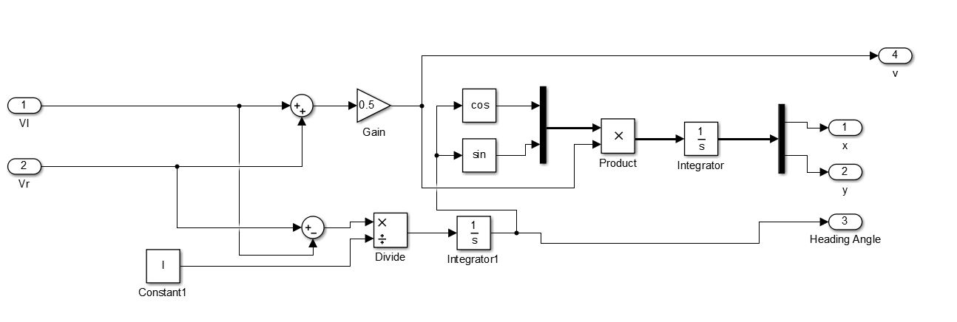

**Problem #2 (5 Points)**

Simulate the proportional control of iRobot Create in Simulink. The robot is required to follow a line defined by *x+2y+3=0*. The robot initial conditions are (*x0* = 5m, *y0* = 6m, *θ0* = 60º). Is there any steady state error associated with this control system? How would you eliminate the steady state error?

*Hint*: check the handout and the simulation in the Robotics Toolbox for MATLAB by Peter Corke.

**ANSWER: See attached simulink schemes below**

Cant seem to get the system to work, but if there were steady state error, a PID or PI controller could be used instead of just a P controller

